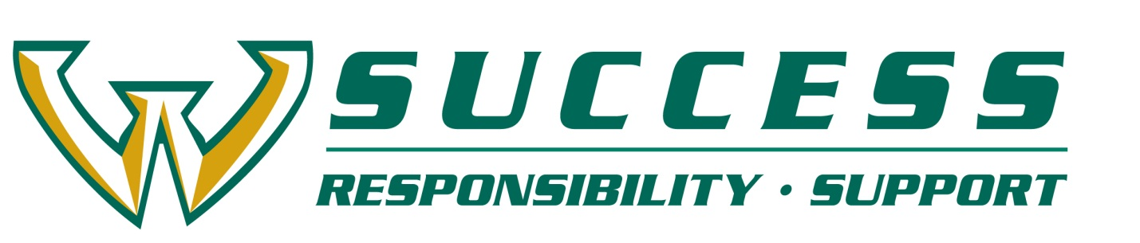

**Assessment Report for 2015-16 Learning Communities**

Each program is required to submit an assessment report at the end of the semester documenting performance on learning outcomes proposed in the Request for Proposals.

**Learning Community Assessment**

1. Name of Learning Community (LC)

2. Primary coordinator:

3. How many students did you start with in fall? (If you have multiple cohorts, note them separately, giving their numbers for their first fall semester.)

4. How many students did you have left in winter?

|  |  |  |  |
| --- | --- | --- | --- |
| Intended Learning Outcomes, specific to YOUR LC in 2015-16 | Met / Not Met | Evidence | How did you gather the data? *(Please attach STARS, Student Voice printouts of survey and results, or other assessment data results)* |
|  |  |  |  |
|  |  |  |  |
|  |  |  |  |

Please send an electronic copy to Amy Cooper ([ao4919@wayne.edu](mailto:ao4919@wayne.edu)). The Final Report is due May 31, 2016.