Academic and Co-curricular template in Planning

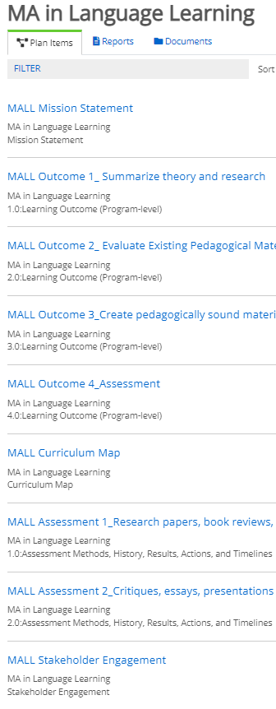
In this document you’ll find an updated and consolidated Word version of the assessment plan items in Planning for drafting and sharing with colleagues. You can find the separate Excel curriculum map template with examples online. Your assessment plan consists of 5 main items:
- Mission statement (1 per program)
- Learning Outcomes (Program-level) (4 per program)
  - Co-curriculars can use the Goal option in place of one or more learning outcomes.
- Curriculum map (1 per program; optional for co-curriculars)
- Assessment methods, history, results, action plan, and timeline (2 per program)
- Stakeholder Engagement (1 per program)

As a reminder, method history, stakeholder groups, and stakeholder engagement plan are required starting in AY22-23. Stakeholder feedback is an optional pilot for this year.

Please contact Cathy Barrette with any questions or comments.

Thank you!

Figure 1. Sample table of contents for a complete plan

Student Support Assessment Plan Templates (F22 launch)

Template 1: Mission Statement
(Requirement: 1 per program)

1.1 Title
Replace the default text with “Mission: [Your Program]” (e.g., Mission: WSU Assessment)

1.2 Mission Statement
Enter a brief (2-4 sentence) mission statement - a brief description of the program’s: Purpose - Why the program exists; Offerings– What services or supports the program offers; Target audience/Stakeholders – Who benefits from the program

Template 2: Learning Outcome (for all) or Goal (for co-curriculars)
(Requirements: Sections 2.1-2.4: 4 per program; Sections 2.5-2.9: 2 per program)

2.1 Number
This value is used for sorting your Learning Outcomes and Goals. Ignore the default text and enter a logical number, word, or code of your choice (e.g., LO1) that can be used to order your Goals/Learning Outcomes.

2.2 Title
Enter a keyword for this goal/learning outcome. Create a separate item for each goal/outcome.

2.3 Learning Outcome Description/Goal Statement
For Learning Outcomes: Learning outcomes are statements of the intended results of the program. Learning outcomes can be cognitive, affective, interpersonal/social, or psychomotor goals. What is one skill, area of knowledge, disposition, or value that students will have after participating in your program? Outcomes should be stated a single, specific, measurable student behavior. (Please create a separate Learning Outcome item for each outcome.)
For Goals: What is one strategic or operational goal for your co-curricular program? Please create a separate Goal item for each goal/outcome. (Academic programs should not use this item.)

Template 3: Curriculum Map
(Requirement: 1 per academic program. Co-curricular programs can optionally submit a curriculum map (Excel template) or an activity-to-goal grid (Excel template) or choose to submit neither.)

3.1 Title
Replace the default text with “Curriculum Map: [Your Program]” (e.g., Grid: WSU Assessment).

3.2 Attach Curriculum Map Here
A curriculum map shows how the program develops students’ learning for each learning outcome and helps identify logical points for assessment. A template with an example is available at https://wayne.edu/assessment/files/curriculum_map_templateacademic_and_student_services_wsu.xlsx.
Please use the "Upload File" button to attach your curriculum map to this field.
Co-curricular programs may optionally submit the Activity-to-Goal Grid (https://wayne.edu/assessment/files/student_support_activity-to-goal_grid_template.xlsx) instead, or submit nothing for this item.

Template 4: Assessment Methods, History, Results, Actions, and Timelines

4.1 Number
This value is used for sorting your Assessment items. Ignore the default text and enter a logical number, word, or code of your choice (e.g., Asmt-LO1) that can be used to order your Goals/Learning Outcomes.

4.2 Title
Replace the default text with a keyword for this assessment method. Create a separate item for each method.

4.3 Assessment Method
Assessment methods are planned processes for collecting evidence. Your method description should explain the process in enough detail that colleagues could replicate it if needed, including information such as the outcomes/goals to be assessed, data collection instruments, student/participant sample, frequency of data collection, scoring criteria, targets for performance, and responsible parties. (See https://wayne.edu/assessment/files/planning_what_to_write_in_each_section.pdf for an easy guide.

+File (attachments allowed)

4.4 Method History
Please make a selection from the pulldown menu for any assessment method that you are actively using this year. (For methods that you do not plan to use this year, you can ignore this item.)
(Pulldown menu options:
- This is a NEW or REVISED assessment method that has not been used before in its current form.
- This assessment method has been used before in its current form.)

4.5 Results
Objectively summarize the results of your assessment in relation to your target outcome/goal, comparing the results to any previous year’s data from this method. State whether those results met your performance target(s). Include (in the box or as an attachment) the de-identified data that your summary represents and mention any context for or problems with the data that are relevant to interpreting the results.

+File (attachments allowed)

4.6 Program Action Plan
An action plan states the concrete actions your program will take in direct response to the assessment results above to improve student learning or success. It also identifies individuals or groups responsible for carrying out those actions. If you are making a change to your program, please mention how and when you will re-assess to see if the change has had the desired positive impact on student learning or success.

+File (attachments allowed)

4.7 Timeline for Action Plan Implementation
The timeline for implementation specifies the due date for completion of each element of the action plan.

Template 5: Stakeholder Engagement
(Requirements: Sections 4.1-4.3: 1 per program; Section 4.4: 1, optional for AY22-23)

5.1 Program Stakeholders
Replace the default text with a "Stakeholders: [Your Program]" (e.g., Stakeholders: WSU Assessment)

5.2 Stakeholder Groups
Please indicate all groups that your program identifies as key stakeholders:
☐ Students
☐ Program colleagues (e.g., faculty, staff, immediate supervisor)
☐ WSU colleagues beyond your immediate program (e.g., your broader unit or division; other units, departments, or divisions)
☐ Non-WSU stakeholders (e.g., community or industry partners, advisory groups, employers, accrediting bodies)
☐ Other (Please explain in the Engagement Plan box below.)

5.3 Engagement Plan
Please briefly describe when and how you will share your program's assessment activities with at least one of your stakeholder groups and how you will gather their feedback.

Examples: (1) Program will hold focus groups with students every October to discuss assessment priorities and recent results; feedback will be recorded in notes. (2) Employers/advisory boards will receive a survey each July that asks for comments on relevant excerpts of the assessment plan/results/action plan to gather feedback and interpretation.

(Feel free to attach related documents, such as handouts or reports shared with your stakeholders or survey and focus group questions, as supplemental information.)

+File (attachments allowed)

5.4 Stakeholder Feedback (optional pilot in AY22-23)
Please summarize the feedback, comments, or ideas your stakeholder group(s) provided about your assessment activities or your program. (Feel free to add an attachment with supplemental detail.)

+File (attachments allowed)

