Coming Sept. 4, 2019: Compliance Assist Assessment Plan “Rollover”

All existing information in Compliance Assist will remain accessible and editable at all times.

On September 4, 2019, some of your program’s 2018-2019 assessment information in Planning (formerly Compliance Assist) will be copied to 2019-2020 to save you time and effort, including your:
- Mission statements
- Learning outcomes
- Curriculum maps
- Assessment methods
- Reporting to stakeholders
You will be able to edit any of these items in the new reporting year if you’d like to do so.

This is a one-time process; any information added to 2018-2019 after Sept. 3 will not be rolled over.

Time-limited (annual) information will be retained in 2018-2019, but not copied to the new academic year (AY19-20). New information must be entered each year for:
- Results
- Action plans
- Timeline for implementation
- Any optional items (Surveys delivered through Baseline, Assessment Plan Feedback, Additional information)

Once the rollover takes place, the default view when you open Planning will be for the 2019-2020 academic year. You can always view and edit previous years by switching to another academic year’s view. (Detailed instructions are available below and online.)

Questions? Please contact WSU Director of Assessment Cathy Barrette (c.barrette@wayne.edu), your University Assessment Council representative, or Campus Labs support (support@campuslabs.com, (716)270-0000).

CHANGING VIEWS TO A DIFFERENT ACADEMIC YEAR IN PLANNING:

Login

Log in to Planning at https://wayne.campuslabs.com/home using your WSU credentials.

The default/HOME view is called the DASHBOARD. The dashboard provides filtered lists of the information you have access to. To see all of your information, change to the Plans view by clicking on the PLANS icon.

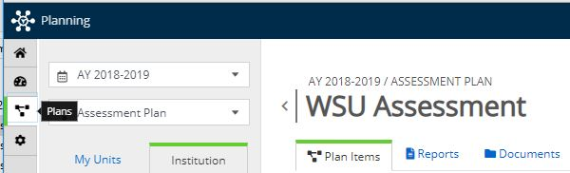
PLANS icon on left navigation bar

Select a Time Period
The default time period is the current academic year. To see previous years’ information, use the pulldown menu at the top left.
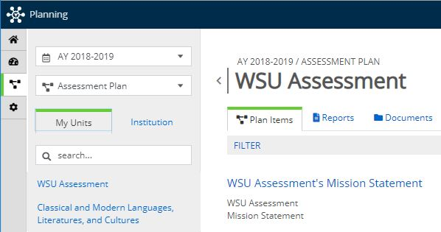
Time Period pulldown menu location

