Instructions for Campus Labs/Anthology Planning (i.e., Compliance Assist version 2)

This document provides basic instructions for using Campus Labs/Anthology Planning (formerly called Compliance Assist) and includes how to:
- Get help with Planning
- Log in
- Navigate to your program(s)
- Select a time period (optional)
- Sort and filter information
- Create and edit items in your assessment plan
- Move items to a different time period or program
- Generate a report

For information about what content to add to Planning and the timeline for each year, please see these other resources:
- What to write (docx) in each section of your assessment plan in Planning.
- The Academic and Student Services Assessment Handbooks, with good examples from WSU programs for each part of the assessment plan
- Annual assessment timeline with Fall, Winter and Spring/Summer deadlines

Get Help with Planning
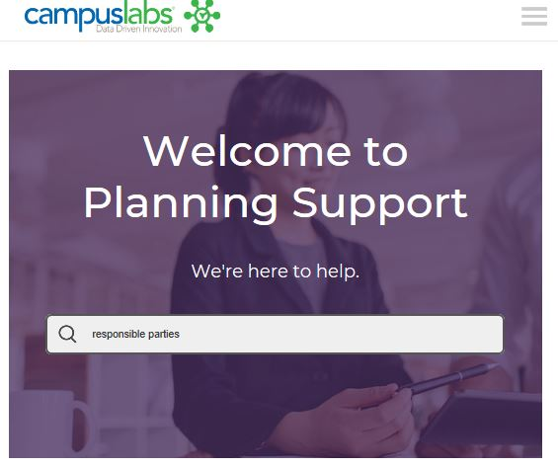
While Planning has a more user-friendly interface than Compliance Assist, you still may run into an occasional question that the instructions below don’t answer. If that happens, help is available from the following sources:
- Cathy Barrette, WSU Director of Assessment (c.barrette@wayne.edu)
- Campus Labs Support, which offers individual help by:
  - Chat (9am to 5pm EST weekdays)
  - Phone (8am to 8pm EST weekdays) at (716)270-0000
  - Web form
  - Email (support@campuslabs.com)
- Campus Labs End User Online Training Modules
Campus Labs Planning support site logo

Login  - Go to wayne.campuslabs.com  - Use your WSU credentials to sign in (AccessID, password)  - Select PLANNING (not Compliance Assist.) | 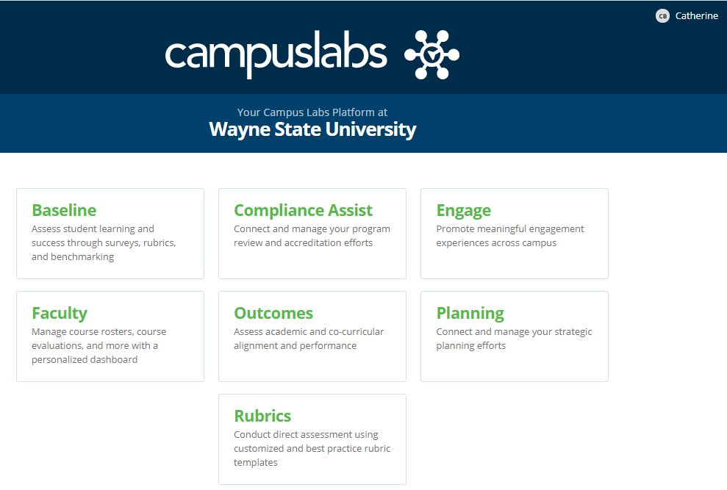

Navigate to Your Program(s)
The default/HOME view is called the DASHBOARD. The dashboard provides a filtered list of information, so is often not the best view. To see all of your information:
- Click on the PLANS icon (the three dots with connecting lines).

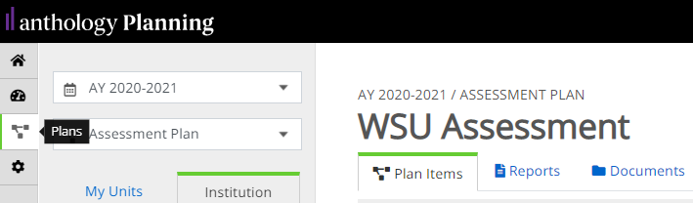
PLANS icon on left navigation bar

- In the MY UNITS tab, click the program in the program list that you want to work on.
(You can also browse for programs under the INSTITUTION tab or find one using the search bar.)
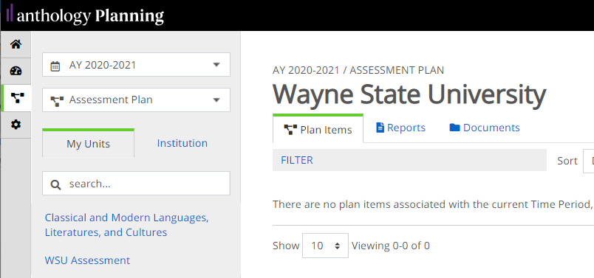
MY UNITS tab and Program List locations

Optional: Select a Time Period
The default time period is the current academic year. To see previous years, use the pulldown menu at the top left.
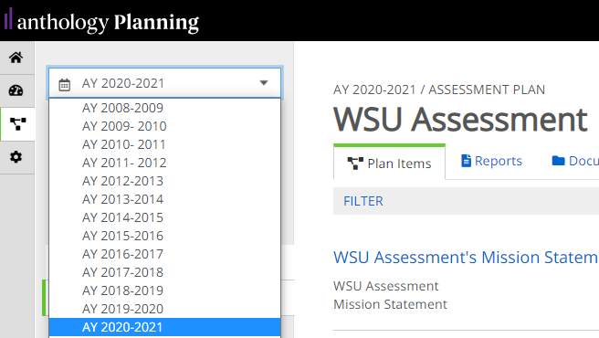
Time Period pulldown menu location

Sort and Filter Your Program’s Information
- To organize your list of items by title, number, or other attribute, use the Sort pulldown menu.
- To select which information to display by progress or item type (AKA, by “template”), such as learning outcomes, use the Filter hyperlink.
- See the Campus Labs instructional article for more detail if needed.
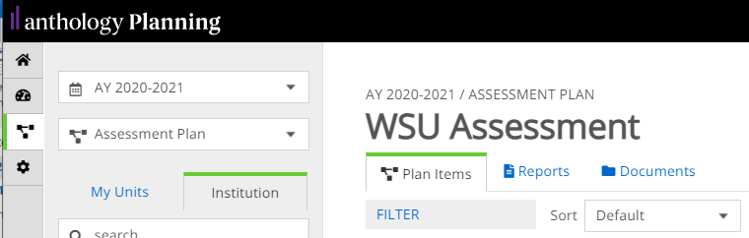
Sort and Filter locations

Create a New Item in Your Program’s Assessment Plan
- Click on + Plan Item to open a menu of items you can add (e.g., mission statement, learning outcomes).
- Select an item to add it. An editing window will open where you can add your content.
  - Information is saved automatically as you work, indicated by a green circle with a check mark in it.
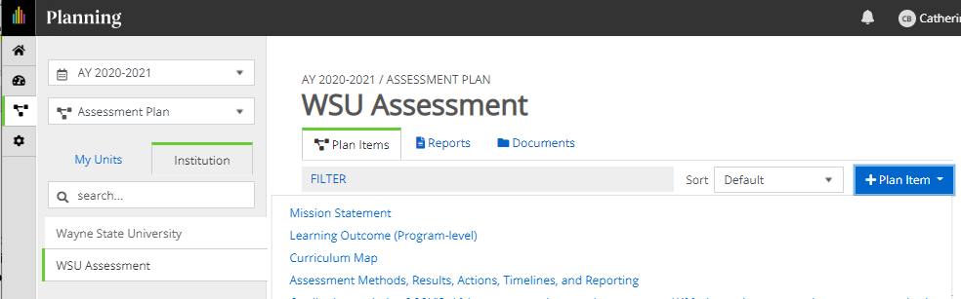
Add a Plan Item button location
3. Optional: You can assign responsibilities for an item to a user under the PERMISSIONS tab when creating or editing the item. Doing so will make the item show up on the user’s dashboard in a Responsible Items list. 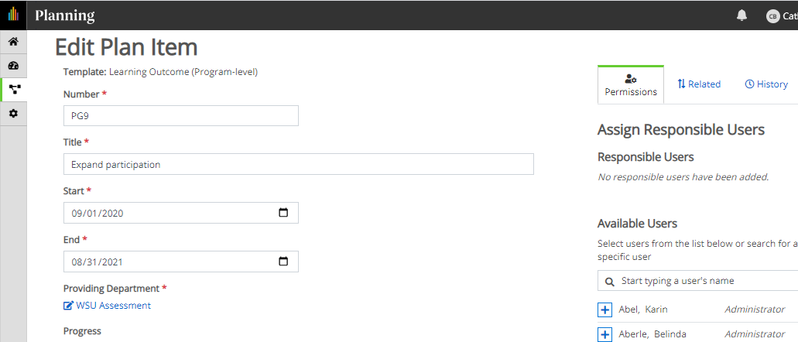

Edit Existing Items in Your Program’s Assessment Plan
- Click on the title of the item you want to edit. An editing window will open where you can modify your content.
- Keep in mind that your assessment items include multiple boxes: for methods, results, action plans, timelines, and reporting to stakeholders. (NB: Reporting to stakeholders will be retired in AY21-22 and replaced with a separate item, Stakeholder Engagement.)
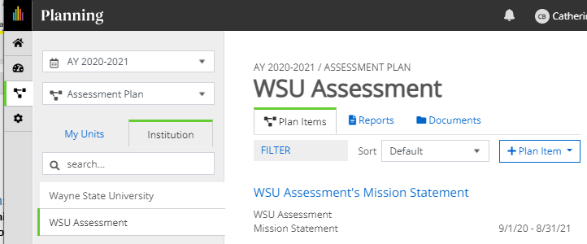
Item title example
- Once you’ve made your changes, you can navigate to the next item or program you want to work on. Clicking “Done” is optional; your work auto-saves regularly.

Move an Item to a Different Year
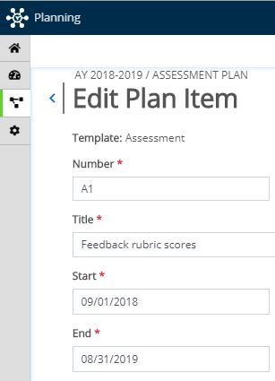
Start and End date locations

Change the Start and End dates to move the item to a different year.
Please use academic year dates only (September 1 to August 31).
NB: If you enter future years, you will not be able to access the item and it will disappear from the current year’s view.

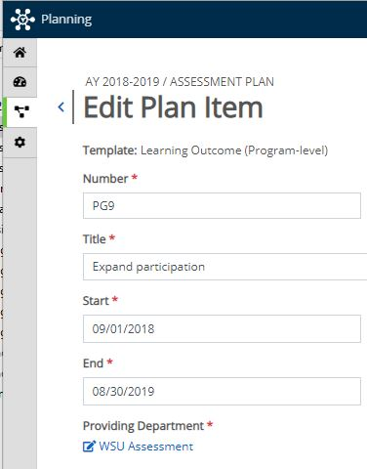
Move an Item to a Different Program
Providing Department location

- Click on the Providing Department’s name. A search box will open.
- Search for the correct department name and select it.
- Click Move Item.

Export or Share Your Assessment Plan
- In the PLANS view, navigate to the program or unit whose plan(s) you want to export.
- Select the REPORTS tab. A list of the reports that you have access to will be displayed. Choose the Assessment Plan Export to export your program’s submissions for a given year.
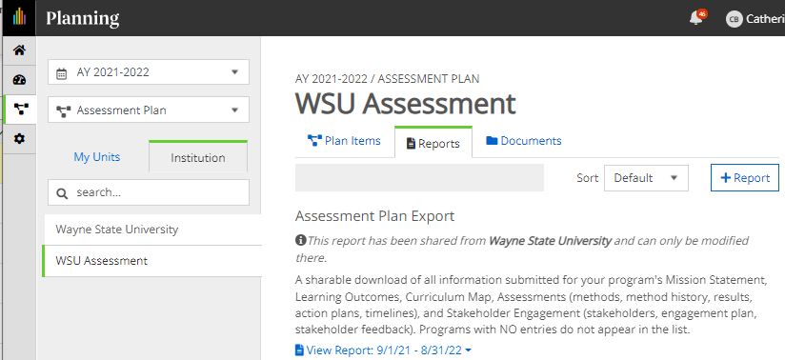
Reports tab location

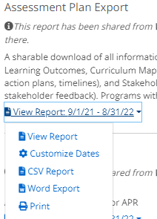
- Click on View Report to reveal a pulldown menu with options for viewing, customizing, or exporting the report in CSV or MS Word formats. The View Report option in the pulldown menu generates a report for the most recent year in the default format, PDF.
NB: Reports will always generate using the current year’s data, even if you are viewing a previous year’s display on your screen. If you want a report from a prior year, you must first Customize Dates under the View Report menu.

Once you click on Customize Dates, then click on and edit the Start and End dates. Only change the years (not the month or day) to the desired one-year reporting period:
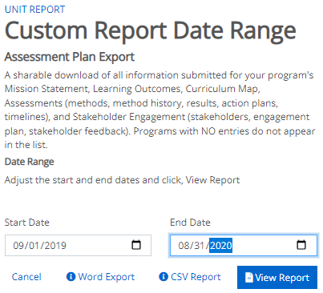
- Once your selections have been made, click on the View Report button to view your report in a new window.
- If you chose View Report, click Print to print/save to PDF, or choose to download a CSV or MS Word file. You can also click Share Item to email a link to the report to another Planning user.

