Instructions for Campus Labs Planning (i.e., Compliance Assist version 2)
This document provides basic instructions for using the new version of Campus Labs (CL) Planning (formerly called Compliance Assist) and includes how to:
- Get help
- Log in
- Navigate to your program(s)
- Select a time period (optional)
- Sort and filter information
- Create and edit items in your assessment plan
- Move items to a different time period or program
- Generate a report

Get Help
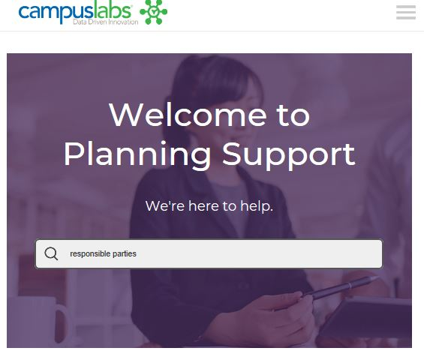
While CL Planning has a more user-friendly interface than Compliance Assist, you still may run into an occasional question that the instructions below don’t answer. If that happens, help is available from the following sources:
- Cathy Barrette, WSU Director of Assessment (c.barrette@wayne.edu)
- Campus Labs Support, which offers individual help by:
  - Chat (9am to 5pm EST weekdays)
  - Phone (8am to 8pm EST weekdays) at (716)270-0000
  - Web form
  - Email (support@campuslabs.com)
- Campus Labs End User Online Training Modules
Campus Labs Planning support site logo

Login  - Go to wayne.campuslabs.com  - Use your WSU credentials to sign in (AccessID, password)  - Select PLANNING (not Compliance Assist.) | 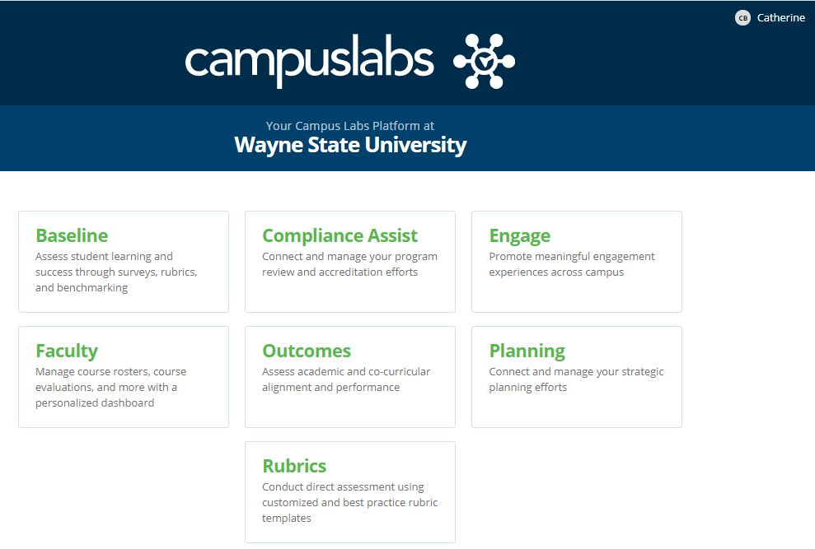

Navigate to Your Program(s)

The default/HOME view is called the DASHBOARD. The dashboard provides filtered lists of information you have access to, so is often not the best view. To see all of your information:
- Click on the PLANS icon to navigate to your program(s).

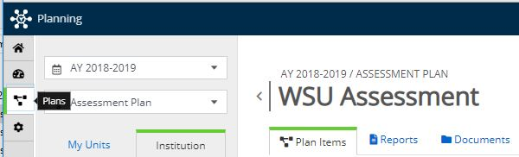
PLANS icon on left navigation bar

In the MY UNITS tab, click the program in the program list that you want to work on.
(You can also browse for programs under the INSTITUTION tab or find one using the search bar.)

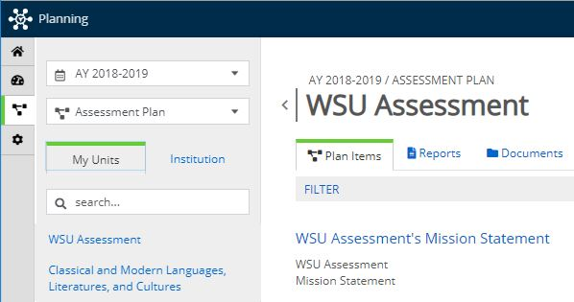
MY UNITS tab and Program List locations

Select a Time Period (Optional)
The default time period is the current academic year. To see previous years, use the pulldown menu at the top left.
Time Period pulldown menu location

Sort and Filter Your Program’s Information
- To sort your items title, number, or other attributes, use the Sort pulldown menu.
- To filter your information by item type (AKA, by “template”), such as learning outcomes, use the Filter hyperlink.
- See the Campus Labs instructional article for more detail if needed.
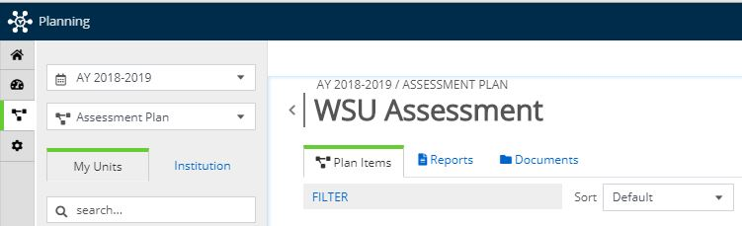
Sort and Filter locations

Create a New Item in Your Program’s Assessment Plan

- Click on + Plan Item to open a menu of items you can add (e.g., mission statement learning outcomes).
- Select the item to add. An editing window will open where you can add your content.
  - Information is saved automatically as you work, indicated by a green circle with a check mark in it.
- Optional: You can assign responsibilities for an item to a user when creating or editing it. Doing so will make the item show up on the user’s dashboard under the RESPONSIBLE ITEMS tab. Campus Labs provides detailed instructions.
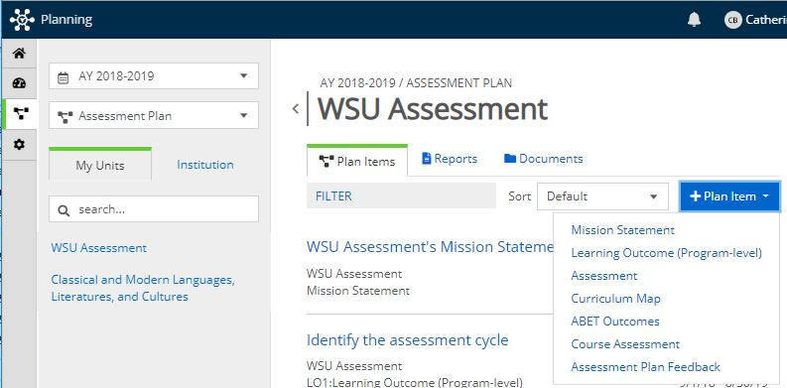
Add a Plan Item button location

Edit Existing Items in Your Program’s Assessment Plan

- Click on the title of the item you want to edit. An editing window will open where you can modify your content.
- Keep in mind that your assessment items include multiple boxes: for methods, results, action plans, timelines, and reporting to stakeholders.
Item title example

- Once you’ve made your changes, you can navigate to the next item or program you want to work on. Clicking “Done” is optional; your work auto-saves regularly.

Move an Item to a Different Year
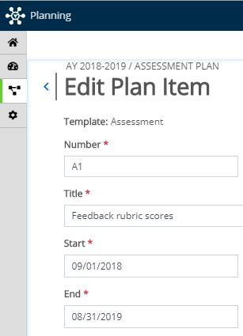

Change the Start and End dates to move the item to a different year.
Please use academic year dates only (September 1 to August 31).

Start and End date locations
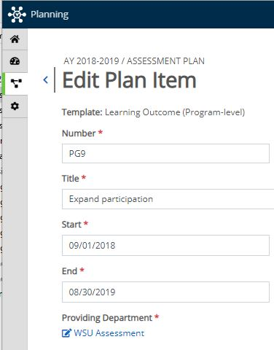
Providing Department location

Move an Item to a Different Program

- Click on the Providing Department’s name. A search box will open.
- Search for the correct department name and select it.
- Click Move Item.

Export Your Assessment Plan
- In the PLANS view, navigate to the program or unit whose plan(s) you want to export.
- Select the REPORTS tab. A list of the reports that you have access to will be displayed.

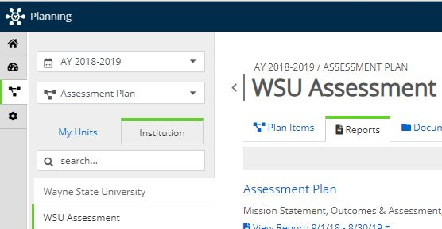
Reports tab location

- Click on View Report to reveal a pulldown menu with options for viewing, customizing, or exporting the report in CSV or MS Word formats.
- Click on the View Report button once your selections have been made. The report will open in a new window.
- Click Print to print to PDF, or choose to download a CSV or MS Word file, or click Share Item to email a link to the report to another Planning user.

