AY21-22 Assessment Documentation Changes
To reduce duplicative efforts and improve assessment practices, two changes are coming to Planning, our assessment reporting system, in September 2021. The details below explain the goals behind these changes, provide a screenshot preview of the new items, and specify the timeline for phasing in each component. There is also a reminder about a past change, the Assessment Planner item, at the end of this document.
For any question, please contact Dr. Cathy Barrette, WSU Director of Assessment, at c.barrette@wayne.edu.
Thank you!
CHANGES TO PLANNING IN AY21-22:
- A Method History checkbox will be added below each Assessment Method item. Why?
- After a program makes a change to its curriculum, pedagogy, or assessment methods, it’s important to ascertain whether that change had a positive impact on student learning so that the program knows whether to maintain that change. This re-assessment process is called “closing the loop.”
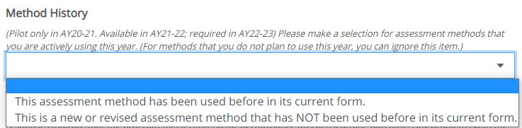
- The goal of this simple item is to encourage programs to notice when they are closing the loop, and then to link current results to results on the same assessment from a previous year or years. It will also facilitate evidence for our accreditation with the Higher Learning Commission.
  - You’ll also see a related note in the Program Action Plan instructions encouraging you to think ahead about re-assessing in the future if you plan to make a change to your program in response to this year’s assessment results.
- This item will be available for you to try out in AY21-22 and will be required starting in AY22-23.

- The existing Reporting to Stakeholders box will be retired and replaced with a separate Stakeholder Engagement item. Why?
  - Reporting to Stakeholders currently appears in every Assessment item, so many programs have unnecessarily submitted the same information multiple times in the same year. The new Stakeholder Engagement item stands on its own, making it clearer that only one submission is required.
  - Historically Reporting to Stakeholders has elicited passive sharing of assessment activities with stakeholder groups or unrelated information. The new item helps programs identify their stakeholders and encourages more proactive sharing and discussion with them. That sharing provides programs with diverse perspectives and feedback on their assessment methods, results, and actions to improve student learning.
Two parts (Stakeholder Groups and Engagement Plan) will be available for you to try out in AY21-22 and will be required in AY22-23:
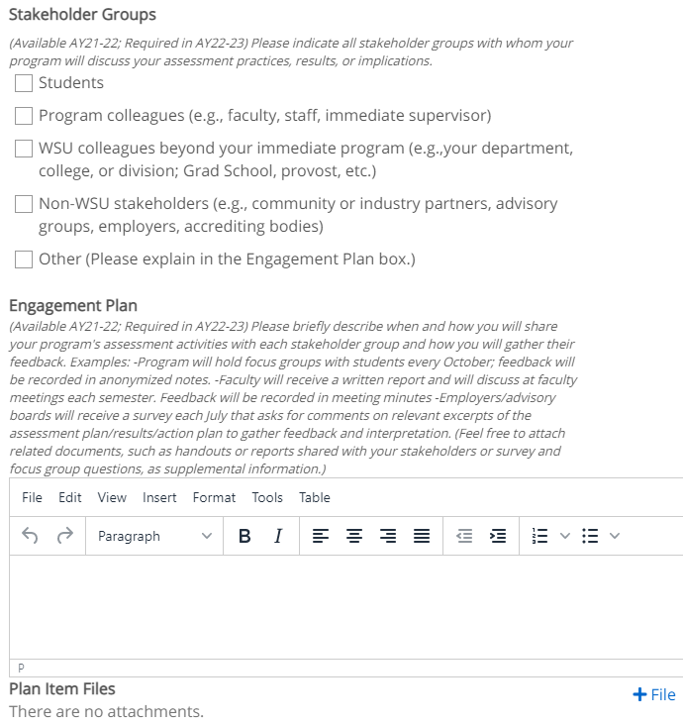
A third part (Stakeholder Feedback) will be available in AY22-23 and required in AY23-24:
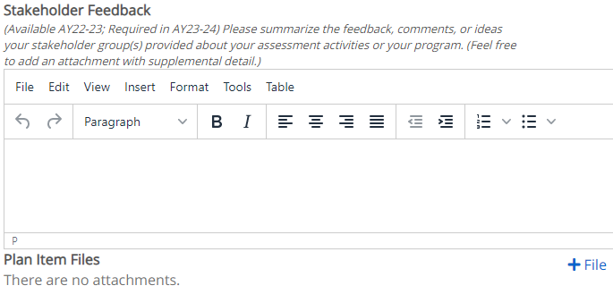

PAST CHANGE TO PLANNING:

As a reminder of a past change, the Assessment Planner item was introduced in AY19-20 to provide space for programs to identify their primary and supporting contact people for their assessments and to support more effective communication and recognition efforts.

If you haven’t done so yet, please add a separate Assessment Planner item for each relevant contact person in your program:

