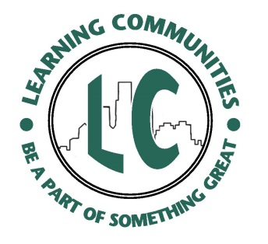
Learning Community Roles and Responsibilities
Learning Community PROGRAM
  - Program Administration, Strategic Planning
  - Collaboration with S/C/D, University Community
  - Training and Professional Development Events
  - IMTPC Application and Certification
  - Marketing and Recruiting
  - Assessment of each LC
  - Funding
Learning Community COORDINATOR
  - Liaison for S/C/D
  - LC Proposal Preparation
  - Content/curriculum development
  - Student Participant Recruiting
  - Management of Peer Mentor(s)
  - LC Assessment
Learning Community PEER MENTOR
  - Confidentiality; Page 10 of the handbook
At training, “what’s said here, stays here”
  - Ethical Standards; Page 11 of the Handbook
PEER MENTORS are ROLE MODELS
  - IMTPC Certification (requirements and events)
- Communicate with your LC Coordinator
  - Specific LC Goals
  - Job description/expectations
  - Schedule regular meetings

