A new, OPTIONAL item in Compliance Assist: Assessment Plan Feedback
By request, we’ve added a new, optional item to Compliance Assist to give programs a place to upload or record feedback you’ve received on your assessment plans.
Comparing your assessment plan to criteria for best practices can improve the quality of information you obtain about student learning and therefore the return on the time you invest in assessment. Actively engaged programs, departments, and other units are increasingly using the assessment plan feedback rubric to provide suggestions about their programs’ assessment plans for this purpose, or devising their own review processes.
Now you have a place in Compliance Assist to keep those rubric reviews and any other feedback you’ve received. A new OPTIONAL item is now available where you can upload a summary of the comments on your program’s assessment plan as well as any supporting documents you’d like to include. Doing so is easy; see the instructions below. (Complete Compliance Assist instructions are online.)
With appreciation for all of your time and effort to improve student learning,
Cathy Barrette
WSU Director of Assessment
Associate Professor of Spanish
Office of the Provost
c.barrette@wayne.edu

INSTRUCTIONS: Add a new Assessment Plan Feedback item to your program’s assessment plan
- Navigate to your program, then click on “New Item” and choose Assessment Plan Feedback from the pull-down menu:

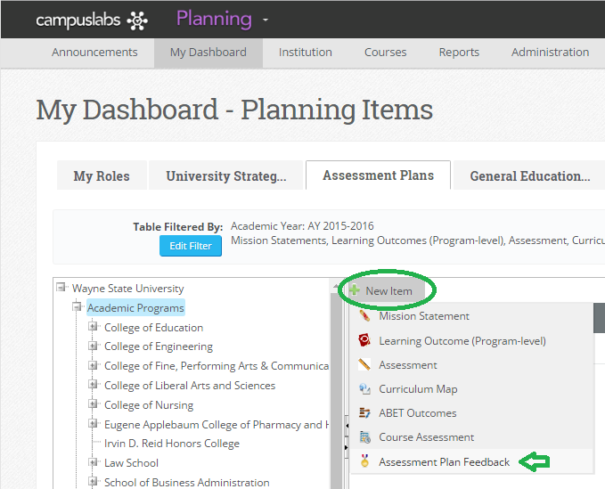

- A form will open in a new window where you can type, paste, or upload your program’s information:
- You must enter a title to save the item.
- You must save before you can add an attachment.
- You must click on the Edit button to enter text or add an attachment.

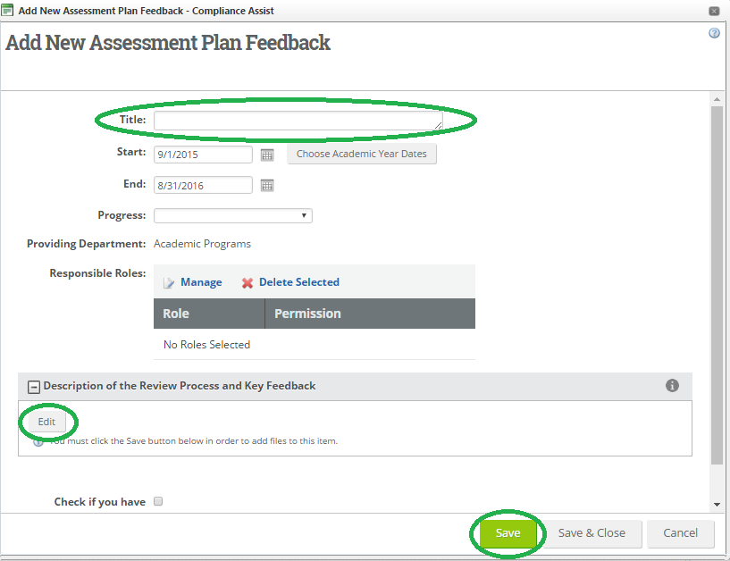

- When you’re done entering information, click on “Save & Close” to return to the Assessment Plans screen. (“Save” lets you continue working in the same window.)

